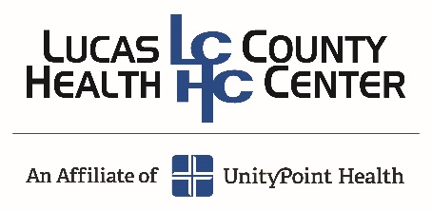

Volunteer Position Description
Title/Position: Gift Shop

Goal of Position: Manage and operate the Gift Shop to help financially support the Volunteer Services Department.

Sample Activities/Duties:
1. Greet customers as they come into the shop
2. Assist customers with purchases
3. Knowledgeable of gift shop inventory
4. Comfortable handling sales transactions and operating cash register
5. Tag and stock merchandise
6. Maintain a clean workstation
7. Light cleaning as needed
8. Help with displays and moving merchandise around shop
9. Tracking and ordering snack items

Time Frame:
Length of commitment: 12 months and at least one shift per month
Length of shift: 4 to 6 hours
Scheduling: 9:00 a.m. to 3:00 p.m. Monday-Thursday
9:00 a.m. to 1:00 p.m. Friday
No Holidays or weekends

Worksite: Gift Shop

Minimum age: 16

Qualifications Sought:
- Must be willing to work in a team environment focused on Lucas County Health Center’s Core Values
- Must be willing to interact with patients and staff in a positive and friendly manner
- Must be able to read and write
- Good verbal communication skills
- Confidentiality is CRITICAL
- Understand how to complete job tasks
- Communicate adequately with patients and staff as necessary
- Understand and follow safety guidelines
- Understand the Volunteer Handbook and all Clinic and Hospital policies and procedures
- Must understand and follow Lucas County Health Center’s Core Values
- Must be able to sit for extended periods of time
- Ability to lift 10 lbs.
- Ability to multitask
- Able to use POS and other computer and internet-based software

Benefits:
- Being a member of a team that focuses on Lucas County Health Center’s Core Values
- Free meal or snack provided during shift at Bistro or Gift Shop
- Discount of 20% at Gift Shop
- Invitation to all LCHC Volunteer Services recognition events, open house, and Hospital Week and Holiday activities

For Further Information:
Contact: Kristine Kennedy, Volunteer Services Manager
Email: kkennedy@lchcia.com Phone: 641-774-3226

Updated: May 31, 2024

